University of Dhaka (DU) Faculty of Engineering and Technology
Department of Electrical and Electronic Engineering


0613-CSE-1206: Computer Programming Laboratory

Lab Assignment (Group 10)
Title: Design and Implementation of a Computerized Cricket Match Scoring System

Submitted By
Group Member:

- SH-168-001, Reg. No. 2024113223, Name: Irtifa Rahman Khan
- SH-168-019, Reg. No. 2024113241, Name: Hossain Mohammad Sabbir
- AE-168-032, Reg. No. 2024713254, Name: Mashruk Bin Islam
- FH-168-038, Reg. No. 2024013260, Name: Mohibur Rahman
- AE-168-039, Reg. No. 2024913261, Name: Nafeem Bin Huda

Submitted To

Dr. Khaleda Ali, Associate Professor, Dept. of EEE, DU. Md. Nizam Uddin Tanim, Lecturer, Dept. of EEE, DU.

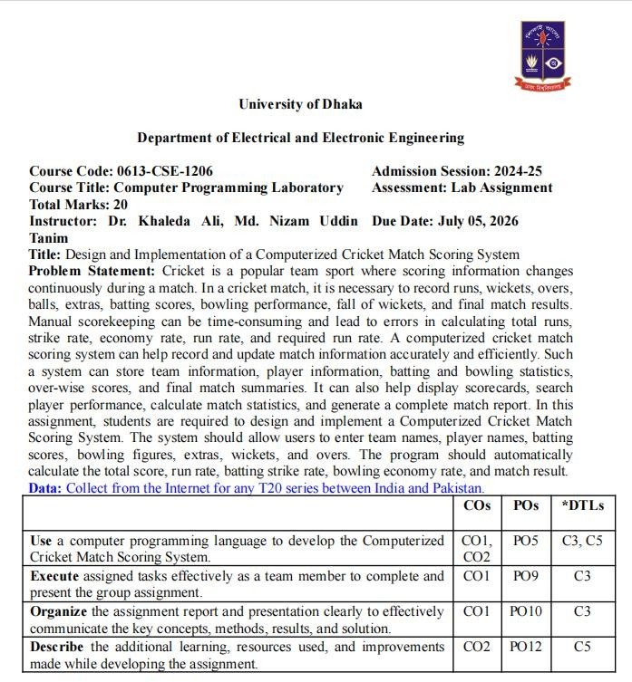

Title:

Design and Implementation of a Cricket Match Scoreboard Management System Using the C Programming Language

Objectives:

- To develop a cricket match scoreboard management system using C.
- To record and manage batting, bowling, and team statistics during a cricket match.
- To calculate and display the match score, player performance, and overall match summary accurately.

Problem Statement:

Cricket is a popular team sport where scoring information changes continuously during a match. In a cricket match, it is necessary to record runs, wickets, overs, balls, extras, batting scores, bowling performance, fall of wickets, and final match results. Manual scorekeeping can be time-consuming and lead to errors in calculating total runs, strike rate, economy rate, run rate, and required run rate. A computerized cricket match scoring system can help record and update match information accurately and efficiently. Such a system can store team information, player information, batting and bowling statistics, over-wise scores, and final match summaries. It can also help display scorecards, search player performance, calculate match statistics, and generate a complete match report. In this assignment, students are required to design and implement a Computerized Cricket Match Scoring System. The system should allow users to enter team names, player names, batting scores, bowling figures, extras, wickets, and overs. The program should automatically calculate the total score, run rate, batting strike rate, bowling economy rate, and match result.

Sample Run:
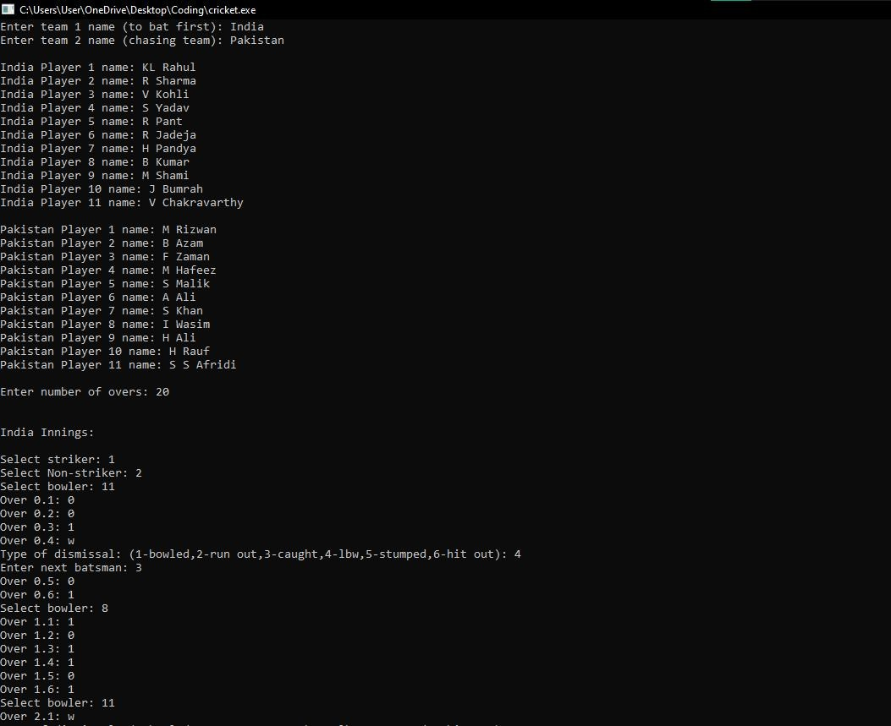

Figure 1.1: Input of the names and the scoring system
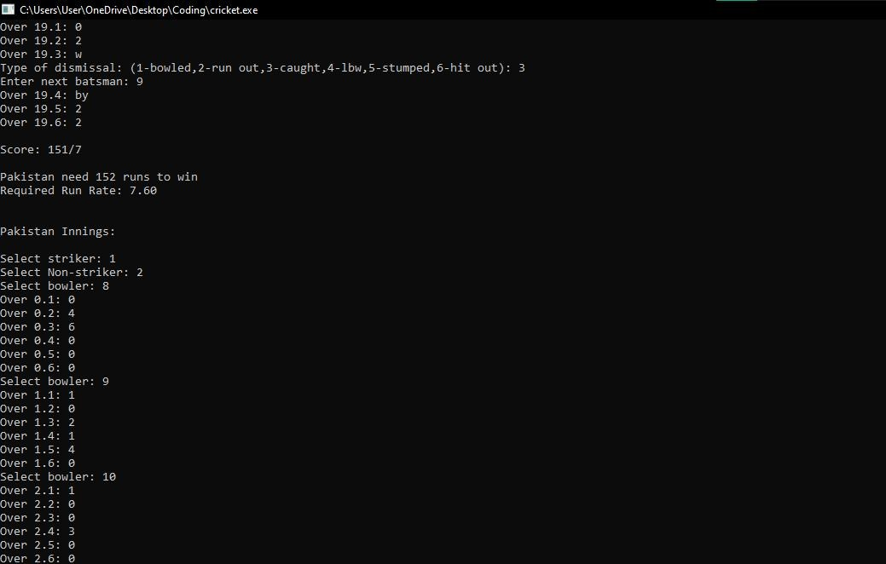

Figure 1.2: First innings result and target setting

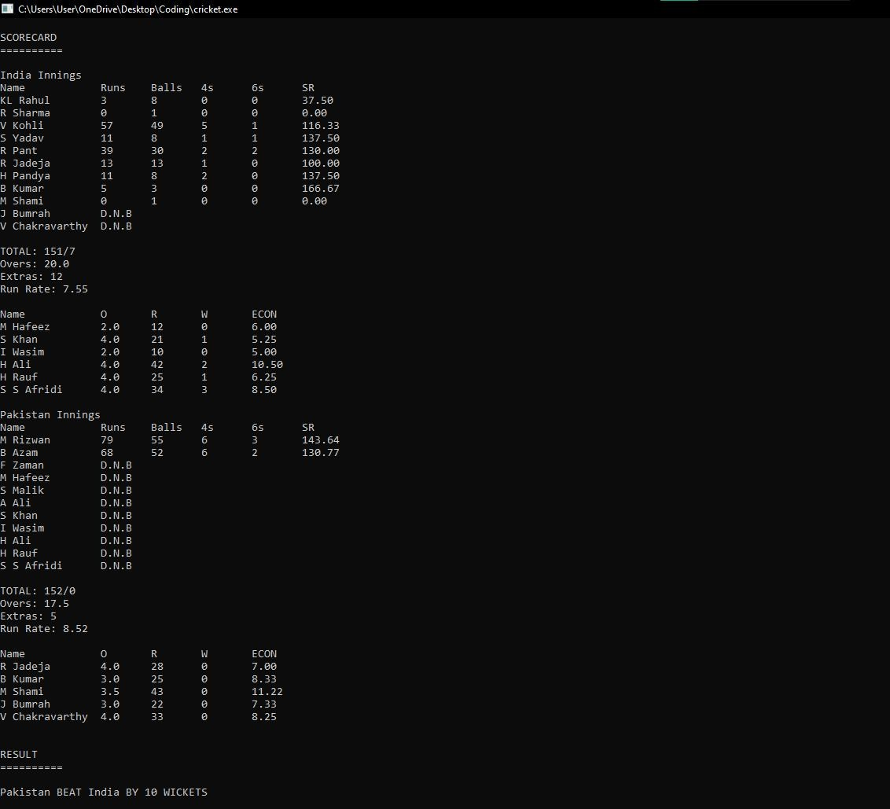

Figure 1.3: Scorecard of the Match

(Ref: India vs Pakistan; ICC T20 Cricket World Cup 2021)

Discussion:

This program is a cricket scoring system developed using the C programming language. Its main purpose is to simulate a real cricket match by recording the score ball by ball while keeping track of both individual player performances and the overall team score.

To organize the data effectively, the program uses three structures: batsman, bowler, and team. The batsman structure stores information such as the player's name, runs scored, balls faced, number of fours and sixes, and strike rate. The bowler structure records the bowler's name, runs conceded, balls bowled, wickets taken, and economy rate. These are grouped together within the team structure, which also stores the team's total score, wickets lost, and extras. This structured approach makes the code easier to understand and manage. …[1].

First, the user enters the names of both teams along with the names of all eleven players. Since every player can both bat and bowl, the player names are copied into both the batting and bowling records. Before the match begins, all statistical values are initialized to zero to ensure that no unwanted or random values affect the calculations. For loops are used in order to track the inputs. …[2].

The user then enters the total number of overs and selects the opening batsmen and the bowler for each over. Every ball is recorded by entering predefined inputs such as runs (0–6), wides (wd), no-balls (nb), byes (by), leg byes (lb), or wickets (w). Based on the input, the program updates the team's score, individual batting records, bowling figures, and extras according to the rules of cricket.

The program correctly treats wides and no-balls as extra deliveries while adding the appropriate runs to the total score. Byes and leg byes are counted as extras without increasing the bowler's conceded runs. The program also updates batting statistics such as runs, balls faced, boundaries, and strike rotation whenever required. For run-outs, the user specifies which batsman was dismissed so that the batting order remains accurate.

The program also manages strike changes throughout the innings. The striker and non-striker automatically swap using temporary variable after odd-numbered runs, certain extras, and at the end of every completed over. Whenever a wicket falls, the user selects the next batsman, allowing the innings to continue until either all ten wickets have fallen or the allotted overs have been completed.

The program demonstrates several important concepts of C, including user-defined structures, arrays of structures, nested structures, loops, conditional statements, and string handling functions such as fgets(), strcmp(), strcpy(), and strcspn(). ….[1].

The second part of the program is responsible for managing the second innings, determining the match result, and displaying the complete scorecard. It follows the same ball-by-ball scoring approach as the first innings while introducing the target chase and winning conditions.

At the beginning of the innings, the program displays the first team's final score and prompts the user to select the opening striker, non-striker, and bowler. Similar to the first innings, every delivery is entered manually using

predefined inputs representing runs, extras, or wickets. The program processes each input and updates the chasing team's score, batting statistics, bowling figures, wickets, and extras accordingly.

A key feature of this section is the implementation of the target chase logic. After every scoring event, the program checks whether the chasing team's score has exceeded the first innings total. If the target is successfully achieved, the innings immediately ends without requiring the remaining overs to be completed. This accurately reflects the rules of limited-overs cricket, where a match finishes as soon as the chasing team reaches the target.

The program correctly handles various scoring situations, including normal runs, wides, no-balls, byes, leg byes, and wickets. Extras are added to the team total according to cricket rules, while bowler statistics are updated only when applicable. Batting records such as runs scored, balls faced, boundaries, and sixes are also maintained throughout the innings.

Different dismissal methods, including bowled, caught, LBW, stumped, hit wicket, and run out, are supported. When a run out occurs, the user specifies whether the striker or non-striker has been dismissed so that the batting order can be updated correctly. If all ten wickets fall before the target is reached, the innings ends with the team being declared all out.

Strike rotation is also managed automatically. The striker and non-striker swap after odd-numbered runs, certain extras, and at the completion of every over. This ensures that the batting order follows the official rules of cricket throughout the innings.

The final section of the program is responsible for generating the complete match scorecard and announcing the final result. After both innings have been completed, the program displays detailed batting and bowling statistics for each team, followed by the match outcome.

The scorecard begins with the first team's batting summary. For every player, the program displays the number of runs scored, balls faced, fours, sixes, and strike rate. If a player did not face a single delivery during the innings, the program marks them as D.N.B.

The program then calculates the team's total overs played. Since bowling statistics are recorded in terms of balls bowled, the remaining balls after dividing by six are displayed as the decimal part of the overs (for example, 18.4 overs represents 18 overs and 4 balls). The total score, wickets lost, overs faced, and extras are then printed to provide a complete summary of the innings.

Following the batting statistics, the bowling figures of the opposing team are displayed. For each bowler who has delivered at least one ball, the program prints the number of overs bowled, runs conceded, wickets taken, and economy rate. The economy rate is calculated by dividing the total runs

conceded by the number of overs bowled, providing a measure of the bowler's effectiveness.

The same process is repeated for the second innings. The batting scorecard of the chasing team is displayed, followed by the bowling statistics of the team that bowled in the second innings. The program also includes a correction for the overs count when the chasing team wins before completing an over. This ensures that the displayed overs accurately represent the number of legal deliveries bowled.

References:

- K. N. King, “Structures,Unions and Enumerations” in C Programming: A Modern
Approach, 2nd Edition, New York, USA: W. W. Norton & Company, 2008, ch. 4, pp. 377-386.

- Imran, S.M.S., & Ahad, M.A.R., “Flow Control,” in Learn Programming with C: An Easy Step-by-Step Self-Practice Book for learning C,1st Edition, New York, USA: Chapman and Hall/CRC, 2024, ch. 2, pp. 46-419.

